



**Assistive Reality**Company, Products, ICO  
Whitepaper 16  
[**https://aronline.io/**](https://aronline.io/)

## What is the purpose of this whitepaper?

The purpose of this White Paper is to communicate who we are, what we are working toward in the software industry, and why we integrate unique features like Ethereum Blockchain storage, cloud CPU processing and real-time 3D object recognition to power data and services within our platform applications. Included in this white paper is the 2018 to 2021 project road-map, a brief overview of our goals in both the Enterprise and Home markets, and a benefits summary outlining the details of what we will deliver to the community and when. If you’re interested in trying out our software, room builds or technology demonstrations head to the Early Access section for more details.

**Contents**

What is the purpose of this whitepaper? 1

Who is Assistive Reality? 3

What are the aims of the project? 4

What is the timeline? 5

Why is Ethereum integration important? 6

What is our vision for professional users? 7

What is our vision for home users? 9

What problem does this project solve? 10

Who are our competitors? 12

Who are our team members? 13

How do I get early access? 14

What technology does Assistive Reality use? 14

How are we funded? 16

Crowdsale / ICO instructions 17

Legal / disclaimer 24

**Assistive Reality stack:**

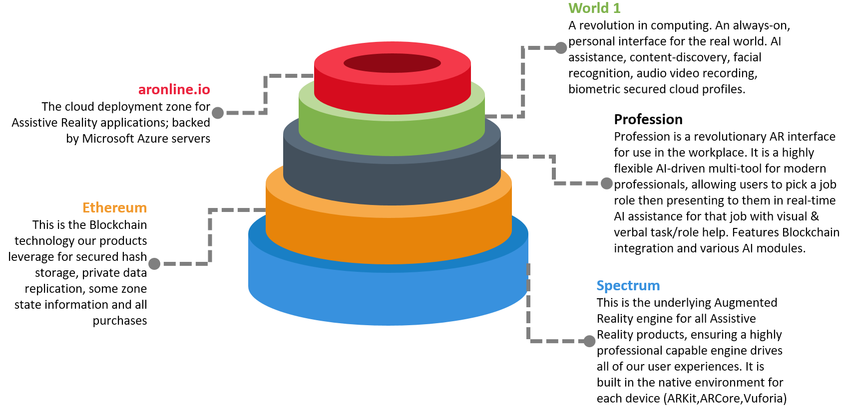

## Who is Assistive Reality?

Assistive Reality is an Australian start-up project created by a team of forward-thinking professionals consisting of Bio and Information-Systems experts with strong experience in user interface design, 3D modelling and a driving interest in human-augmentation technology. We believe AR/MR/VR technologies will have a significant multiplier effect on human achievement.

As highly enthusiastic AR/MR/VR users and developers, we recognise the incredible potential of Augmented Reality technology to improve the lives of professional and home users around the world. We feel AR and MR hardware is reaching early maturity and the timing is right to launch a dedicated Augmented Reality software company now, with the goal of delivering advanced multi-platform AR & MR software to new devices releasing beyond 2017.

Assistive Reality gets its name from our concept of creating applications that will use intelligent AI, device sensors, and cloud-computing to provide assistance to humans in their professional lives and in the home. We aim to push the boundaries of software, hardware and human integration to develop new solutions to problems currently consuming significant human time or effort.

We’re currently in the start-up phase, fine-tuning alpha code on the Microsoft MR and Apple AR SDKs, while working on establishing Google AR compatibility in the coming months. Our team have been very active forming foundation partnerships with companies aiming to deploy enterprise-integrated AR/MR or VR solutions, and achieving commercial agreements to create dedicated applications to meet enterprise workflow and social requirements. These partnerships will be announced via our press portal ([https://aronline.io/press](https://aronline.io/press/)-releases) in future.

A number of our members are cryptocurrency advocates who have experience coding smart contracts and distributed applications on the Ethereum Blockchain; our projects utilise the Ethereum Blockchain for a number of features such as Biometric security and Hash storage. Our aronline.io platform (live Q2’18) uses ETH and ARX tokens as the default currency for license purchases. We aim to increase awareness of Ethereum and advance the development of Ethereum distributed applications throughout the enterprise.

All members of our team have strong experience building and nurturing relationships with government, defence and corporate organisations which will be crucial to our initial success. We will leverage our wide-ranging contact base across Asia-Pacific and China to gain early trials and secure demand for our AR applications. To improve enterprise integration options we’ve architected features such as cloud (Office 365, AWS) and local Directory Service integration, OS policy enforcement, Blockchain secured biometrics and building-integration.

Our plans for Augmentation technology are not limited to optical headsets; we are also actively researching and creating software prototypes to implement building-wide AR environments, and creating partnerships within the optics industry, with the goal of deploying code to run on contact lens or implant technology systems as and when they become available.

Individually, we’ve previously built messaging systems, interactive meeting rooms, smart-mirrors, chat bots, AI systems and object tracking software; by leveraging these skills to ensure we are early to market on a number of a corporate products and by delivering a user experience that is of the highest quality, standardised across hardware platforms, **our aim is to become the industry leader.**

## What are the aims of the project?

* Complete development and compatibility testing of our Spectrum Augmented Reality engine
* Contract to deploy 15 Spectrum application sites within 2018
* Ensure our Spectrum-based Profession apps reach top 10 rank/major app stores within 2019
* Ensure our World 1 world browser reaches top 10 rank/major app stores within 2019
* Develop partnerships with leading hardware vendors in the Augmented Reality industry
* Establish preliminary relationships within the contact lens design and production industry
* Act as a catalyst for the adoption of AR/MR/VR technology in business
* Work on the establishment of interface standards for the AR/MR/VR industry
* Increase commercial awareness and adoption of the Ethereum Blockchain & smart contracts
* Provide an example of ICO fundraising bootstrapping a successful Tier 1 technology firm
* Continue to expand workforce and secure market share in the emergent AR market

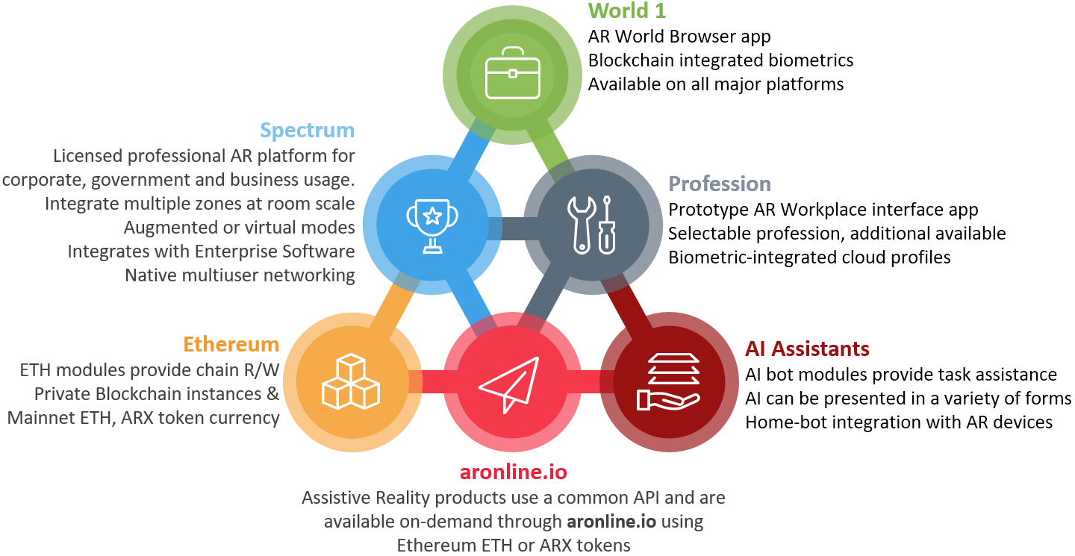

Increased adoption of AR/MR/VR has been delayed awaiting a number of incremental technological improvements; client-device internet bandwidth has required upscaling to enable effective cloud app distribution and real-time high fidelity content streaming; CPU-task offloading is more viable beyond 2017 due to the reduced latency and increased throughput of modern optic fibre, 4G/5G mobile and VDSL consumer networks; Blockchain usability has improved dramatically through Ethereum’s use of distributed applications, smart contracts and EVM processing techniques. Optics and sensor technology has taken great strides, with lightweight mounting options available. These progressions in the technology landscape are the underpinning of a revolution in the basic computer/user interface paradigm. Our ability to use multiple camera and sensor inputs to drive software connected to high speed cloud services with near-instant access to worldwide distributed databases represents a point in time at which many technologies will branch into new territory.

## What is the timeline?

In the first 24 months we are aiming to establish the Australian division of the company **Assistive Reality** to facilitate research, development, deployment, demonstrations and licensing; we have also committed to a number of foundation site clients and interested parties to deliver the following clear outcomes by our March 2019 “**Deploy**” milestone:

* Perform ICO (**ARX** token), fund company structure, establish development contracts
* Demonstrate Spectrum alpha software running with sample tasks at various trade events
* License 5 Foundation Sites for Spectrum deployment trials in early 2018, ramping up to 15
* Release Spectrum beta to foundation sites, monitor and adjust onsite
* Release World 1 beta World Browser for Google AR, Glass, Microsoft AR/MR and Apple AR
* Perform World 1 closed alpha test of large-scale multiuser networking
* Deploy Ethereum smart contract to public main net for exchanging **ARX** tokens for World 1 access or Spectrum licenses
* Begin advanced AI-in-AR research paper regarding in-world and in-zone automation
* Publish a research paper discussing the future-state of human visual augmentation
* Scale development up to 3 full-time development team members
* Test private Ethereum Blockchain secure-storage smart contract functions

We have segmented and summarised some milestones from the first 4 years of operation into clear **Startup, Disrupt, Deploy** and **Scale** phases, as shown below:

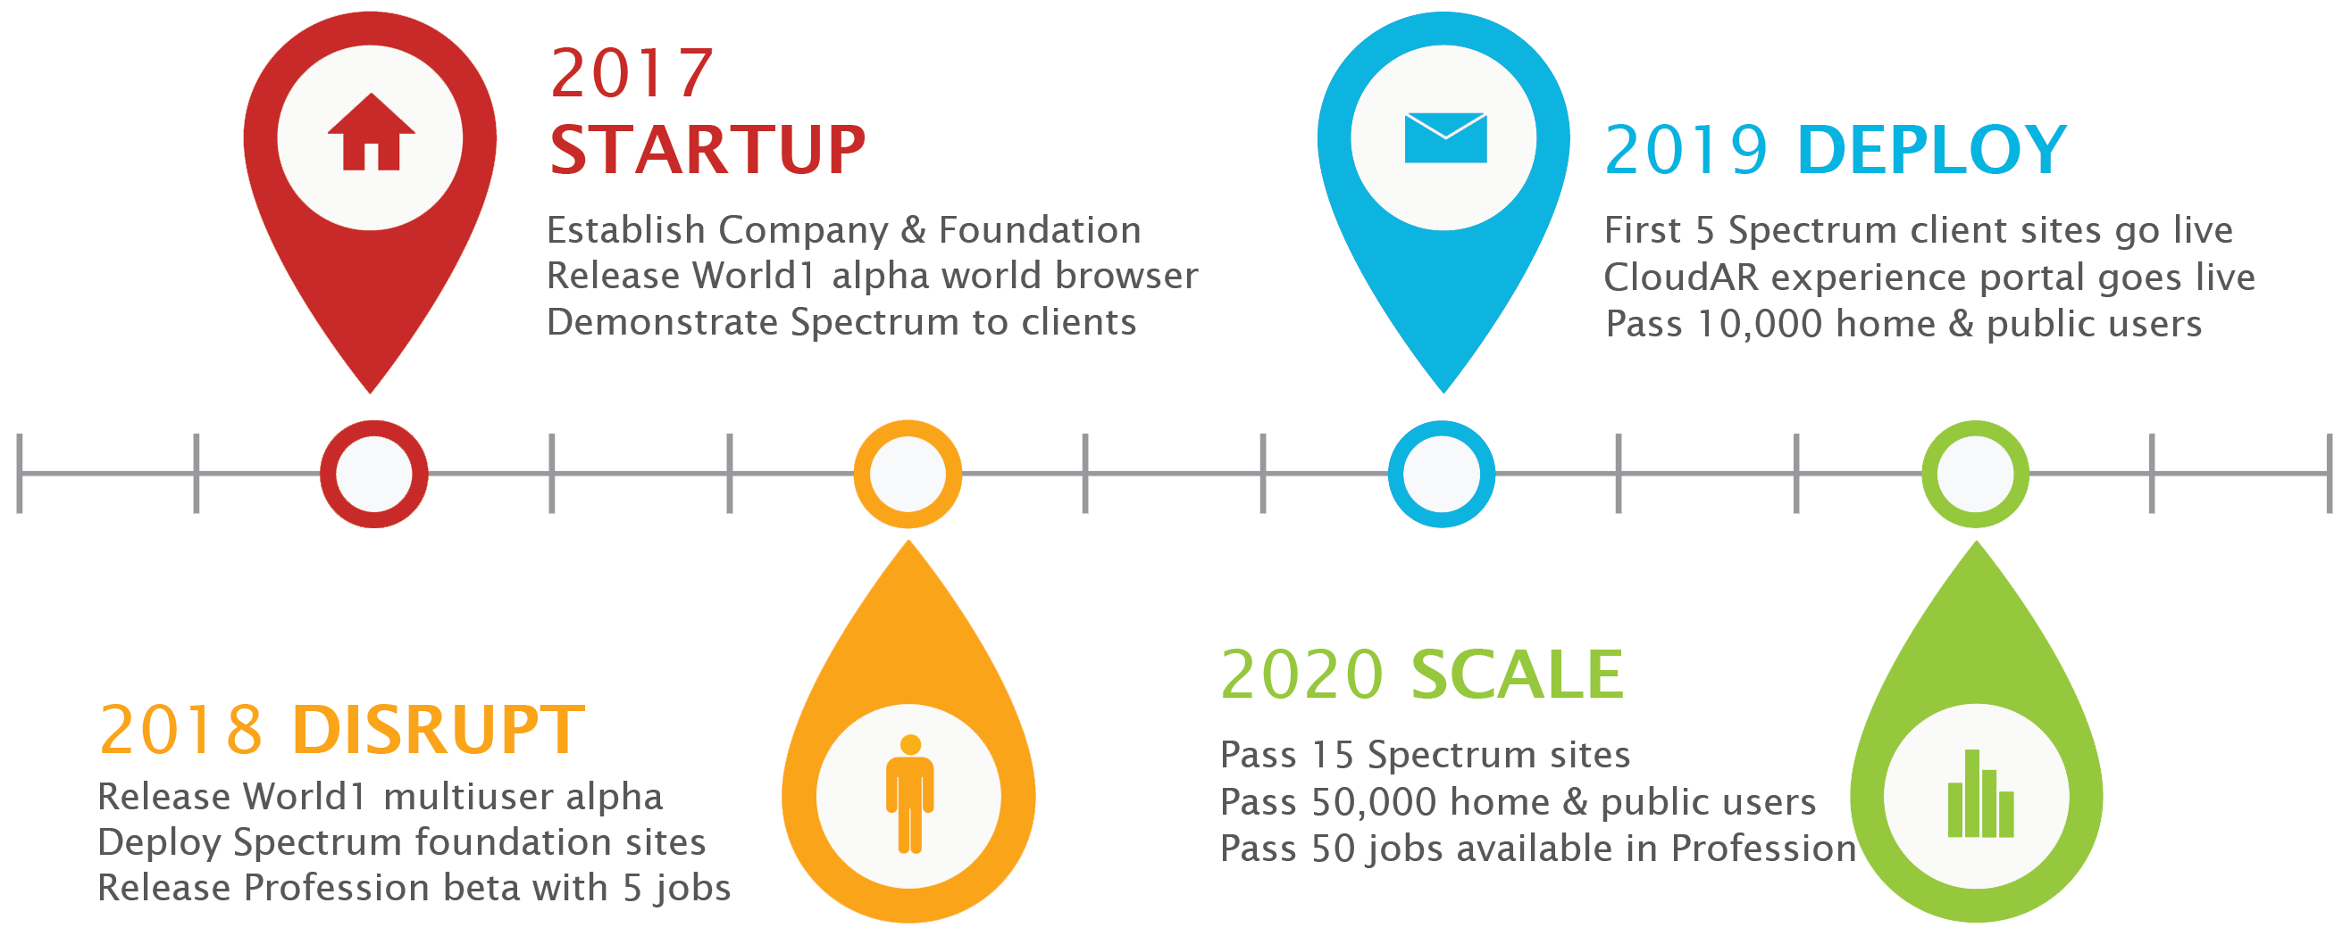

Our initial operational emphasis is twofold; (**1**) To develop and deploy our Spectrum AR engine to major corporations around the world, either standalone or in combination with comprehensive solutions including room-integrated hardware (spatial sensors), audio systems, open AI bots and backend Ethereum Blockchain services, and (**2**) To develop and distribute World 1; the first AR World Browser application to be available simultaneously on all major platforms to allow home users to explore the real world through a dynamic visual interface, with a range of advanced functionality. It is also expected World 1 will allow the user to discover applications, live content and participate in AR World zone activities made available through social media or web pages/stores.

## Why is Ethereum integration important?

Ethereum is a leading cryptocurrency in 2017 and has many advanced features including Turing-complete smart contract scripting and sandboxed code execution. Ethereum’s EVM programmability has contributed to the rise of many distributed applications and offers unique integration options for AR/MR applications. Building our software with native support for Ethereum technology provides the following benefits for our users:

* Private or Public Blockchain-secured Biometrics for each user provide security, audit trail, and data survivability with integrity beyond a typical private database
* Swarm technology is leveraged for roaming user data and some profile information
* Smart contracts are executed using distributed computing (nodes) allowing a degree of processing-offload for miniaturised devices
* Ethereum configurations are already available within major cloud provider services, giving immediate, well-understood scaling when storing data for enterprise client solutions
* Ethereum has a strong development roadmap and community, with good leadership, which has led to widespread trust and adoption across a range of platforms, by a variety of internationally-respected companies; integrating with Ethereum allows us to work with a proven community of professionals with established toolsets and practices, increasing consistency and standardisation

Users of our World 1 world browser will utilise Ethereum integration to interact with paid content in the same way a credit card enables in-app purchases for a traditional Store. We are currently experimenting with coding techniques to use the Ethereum Blockchain itself to track the state of individual AR Zones with various lazy-write cache mechanisms. Direct interaction with Ethereum smart contracts is high on our development priority list for World 1 and Spectrum, with complete Ethereum Blockchain integration (inbuilt wallet for each headset user profile, gesture and basic biometric private key support) coming before the March 2019 release milestone. The array of possible usage cases for Blockchain-integrated AR applications is limited only by imagination; one example is a Doctor entering a hospital room to examine a patient in a modern AR-equipped hospital. As the Doctor enters the patient is automatically identified by sensors on the Doctor’s optical device and a patient retrieval smart contract is called to obtain the details of their current stay. The smart contract examines the list of approved requestors for this patient ID on a Blockchain to locate the key provided by the Doctor’s device to allow the retrieval of medical history. The current chart/info for the patient may be sourced from an existing Enterprise health care management product; seamlessly retrieved in the background and presented to the doctor as an eyes-up information stream.

* **ARX** tokens issued in our ICO can be exchanged using the redemption smart contract for World 1 and Profession early access
* **ARX** tokens and ETH can be used to interact with paid content in all Assistive Reality consumer-facing applications, including AR zones that contain premium content
* Ethereum’s developer community will be directly leveraged to hire coders and testers for smart contracts and Blockchain integration when building World Zones and assistive AI Bots
* As an early developer and integrator, Assistive Reality aims to gain significant market share within Government, Defence and Corporate organisations, exposing them to Ethereum technology potentially for the first time, expanding the reach of Ethereum in general

## What is our vision for professional users?

We envisage professional usage of Augmented Reality to occur at a large scale; car production factories, construction projects, law enforcement, education and health care are all examples of sectors that can benefit enormously from intelligent augmentation software solutions.

For professional users, we provide two options during 2018/2019;

1. Engage with us to plan a custom-built application/suite based on our bespoke Spectrum platform with onsite hardware integration, AR/MR zones, room-scale VR facilities, Ethereum Blockchain integration. This option is recommended for larger companies who have significant facilities or high staff numbers. The following diagram shows the engagement process for a partner company who desires a customised commercial-grade Augmented Reality/Mixed Reality solution:

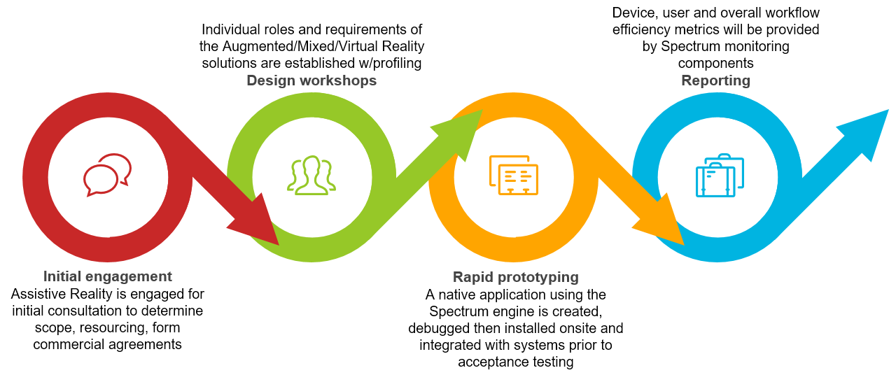

1. Purchase the Profession application from the app store on your device; this is our prebuilt user-customisable application. Profession is recommended for smaller companies or other users that may be performing a work activity and is available with alternative UIs and a selectable list of professions.

Profession features include:

* Switchable user interface (for different job roles, or preferences)
* Professions to select will be added regularly
* Surface-to-screen projection
* AI-bot or Virtual Assistant
* Fine-tuned UI/UX for each profession type
* Guided Action with prompting
* Real-time Communications
* App integration
* Blockchain Recording and Archiving
* Room and Dimensional-space scaling

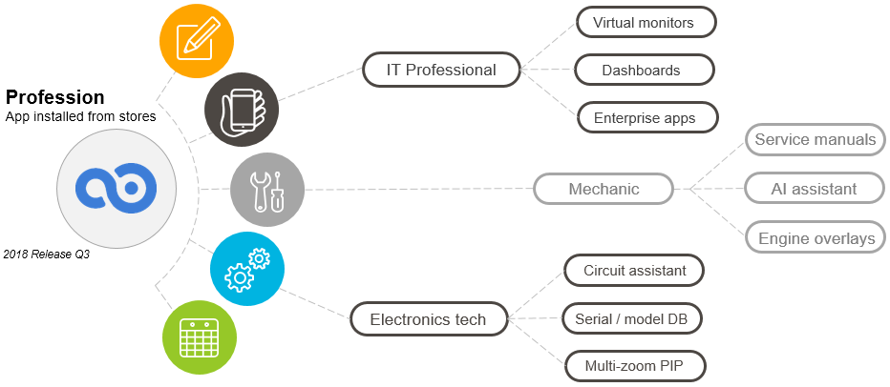

*Example of features for different professions*  
  
  
Innovative software implementation of these features can revolutionise day to day activities in a vast number of companies. It is important to note the Profession application and its interfaces/plug-ins are running on a consumer version of our Spectrum engine. Spectrum is a bespoke Augmented and Mixed reality application engine developed from the ground-up **on each major platform** (Google AR, Apple AR, and Microsoft AR/MR) to provide significant professional-focused advantages over traditional SDK developed applications. The beta release of Profession is targeting the following high level AR feature support on Google, Apple and Microsoft devices, with some variance based on final specifications and individual model capabilities:

|  |  |  |
| --- | --- | --- |
| **Metric** | **Available** | **Type** |
| Max. capture distance / marker | Yes / Variable | 4.5m / 5.5m |
| Minimum angle reconciliation | Yes / Variable | 35-40 degrees |
| 2D Recognition w/stability hold | Yes | Native & Cloud |
| 3D Recognition w/stability hold | Yes | Native & Cloud |
| Geolocation | Yes | Native |
| SLAM-based tracking | Yes | Native |
| Biometric security | Yes | Native & Ethereum Blockchain |
| Directory integration | Yes | Microsoft & Cloud |
| Cooperative multiuser | Yes | Native |
| Large/data storage | Yes | Cloud & Ethereum Blockchain |
| CPU offload | Yes (Optional) | Cloud |
| Blockchain currency integrated | Yes | Ethereum ETH & **ARX** tokens |
| Blockchain applications | Yes | Ethereum smart contracts Distributed apps coming late 2018 |
| Multiplatform | Yes | Native |
| Developer API and Store | 2019 | Scheduled for 2019 |

Throughout 2018 Assistive Reality will be performing onsite deployments of Spectrum-powered custom applications with Government, Defence and Corporate clients in Australia to generate demand and secure licensing contracts for 2019. Each implementation will utilise a Spectrum-based AR/MR/VR solution using the 2018 beta interface, AR zones, backend Ethereum Blockchain storage and include onsite training. Spectrum-based applications feature a consistent look, feel and set of user input conventions to ensure there is minimal retraining requirements when staff move between roles within a company. Deployment to our foundation clients will provide us with real-world deployment feedback, engineering and development partnerships, and allow us to fine-tune user input and fatigue-management techniques.

## What is our vision for home users?

For home users we are releasing our flagship multiplatform application for AR/MR devices called World 1. World 1 is the first multiplatform use-anywhere AR/MR World browser**.** Our vision of the world browser is that it is a passive user interface for the Augmented Reality wearer, to provide un-obtrusive assistance for anything and everything; detecting objects in the real world and using cloud-CPU processing to match object motion with real-world task assistance profiles, presenting content designed to assist the wearer, such as the provision of passive metrics like distance-to, depth, colour values, or even real-time facial emotion analysis. A real-time HUD for the real world. There are many possibilities such as dedicated task zones based on physical location, networked task coordination for groups of people, visualisation of building plans, 3-dimensional virtual object sharing; once Augmented Reality devices are sufficiently unobtrusive and socially acceptable, this technology is expected to be significantly transformative.

High on our development priority list is ensuring World 1 is fully compliant with all upcoming standards for accessing content in AR and VR Worlds. After installing the World 1 application from the device’s native app store, a user can activate their AR/MR device and utilise the dynamic nature of the browser interface and real-time cloud-based sensor analytics to navigate the real world while remaining open to augmented content. For Augmented or Mixed Reality devices, it’s easy to imagine a world where you can walk around your home using voice or gesture commands to assign a virtual screen to a blank wall of your kitchen, perhaps showing a HTML page with a recipe while you cook. A recipe application or plug-in executed by World 1 can use the device’s native sensors to observe the ingredients as the wearer makes the meal, and use Guided Action prompting to guide the wearer through the process. Outside the home, walking to a nearby bus station grants the wearer the benefits of live 3-dimensional object recognition highlighting points of interest along the way; the bus station distance and time remaining to walk, with a transparent-hover to launch the native Android or iOS bus timetable application in-place, giving non-intrusive information to the wearer with low data and processing requirements. Individual native applications can be rendered to floating bubbles or other virtual screens. Any surface in the real world of sufficient dimensions and reflective properties can be marked as a desktop workspace or virtual screen to which a variety of cloud or local sources can be connected. Assistive Reality will work with the Ethereum development community to encourage the development of Blockchain-based consumer applications for both the Augmented/Mixed and Virtual Reality modes of World 1.

## What problem does this project solve?

Augmented and Mixed Reality environments represent an important juncture for computing system interface design; this project aims to solve many basic problems with AR/MR/VR technology adoption in the home and Enterprise, including:

* **Problem**: Workplace Implementation of possible AR/MR/VR technology assistance is not performed due to a lack of internal resourcing specifically for these technologies; companies usually do not have available internal personnel with skills and time to develop advanced workplace AR applications, zones and experiences or to adjust workflow to best leverage new AR/MR/VR technologies; nor to evaluate an entire developing market to keep track of hardware updates as required for making the best-informed decisions.

**Our solution:** We have developed our Spectrum engine alongside a consulting and implementation framework that ensures we can transform large or small companies with advanced Augmented Reality technologies including applications, hardware sensors, building automation, workflow mapping and application connectivity. Assistive Reality team members will attend all rollouts of Spectrum custom applications. Spectrum is a bespoke engine to power Virtual, Augmented and Mixed Reality applications for enterprise and industrial environments. Spectrum is designed to provide a fluid, feature and content-rich, industry-leading AR/MR/VR experience within each client environment. Using advanced technology such as integrated Blockchain biometrics, Ethereum compatibility, cloud CPU-processing offload, directory service integration, 3D recognition and multi-user networking, Spectrum can provide today’s workplaces with significant productivity gains and encourage employee retention.

* **Problem**: Cross-platform user interface standards are not clearly identified (or do not exist at all in some cases) and the user experience can vary significantly between devices, and between applications on the same device.

**Our solution:** BothWorld 1andSpectrum are built using native code on each major platform, and feature a high performance API layer and standardised user interface conventions. Our API layer is intended to allow rapid porting of applications either between devices or to new iterations of a device. We are ensuring a great degree of effort is put in to ensure (to the largest extent possible) shared codebases.

* **Problem:** Integration with Enterprise environments (Microsoft Office 365, Microsoft Active Directory, Amazon Web Services, Azure hosting) is low to non-existent

**Our solution:** Spectrum features enterprise grade directory service integration with Microsoft Active Directory, Microsoft Office 365, AWS Directory Services and Azure AD hosting. Advanced integration with various Enterprise applications such as Exchange and Skype for Business is also available on Microsoft AR/MR/VR headsets.

* **Problem:** AR/MR/VR versions of applications often take the form of vendor-provided 3D AR/MR/VR extensions, and recommend their users view 3D AR/MR/VR content through a 2D smartphone screen, proprietary device or dedicated viewer application.

**Our solution:** World 1andSpectrum are built from the ground up to be fully immersive Virtual, Augmented or Mixed Reality applications in an enabled 3D/4D world space, utilising a combination of each native SDK, the shared platform codebase of Spectrum and custom application plugins or frameworks to create the experience for client workplaces.

* **Problem:** Back end storage options for VR, AR or MR applications on some platforms do not exist; on others they are limited to either slow-local or small-remote storage.

**Our solution:** Our combination of tiered data centre storage and encrypted on-Blockchain options gives World 1 and Spectrum a significant advantage in speed and capacity compared to direct AR/VR competitors. We take a similar approach to others in storing hash values on the public chain using a secure encryption and then store actual data in a zero cost back-end tier system comprised of Ethereum Blockchain, and Microsoft SQL (for some high availability functions)

* **Problem:** There are social concerns about wearers of AR devices in public such as Google Glass using the integration and high fidelity cameras to retrieve personal information about others.  
    
  **Our solution:** One early concept we have is called BlockAR, consisting of a mobile app available on all platforms, which activates a Bluetooth beacon or hidden wireless SSID on the device our standards-compliant AR applications can detect and automatically disable features that may violate privacy (there are known issues with this implementation strategy). A second concept is a physical tag on a piece of clothing that contains a marking detectable by the wearer’s optics, which renders the wearer immune to facial recognition and other biometric comparisons. A third option could be cloud-based immunity; we believe it is likely a combination of these strategies and a new unknown strategy may also be employed in the near future.
* **Problem:** There aren’t many professional, enterprise workplace applications making good use of AR/MR/VR yet and many companies are beginning to form AR/MR or VR strategies now without partners or enterprise products to give them the ability to meet their requirements  
    
  **Our solution:** We will be pushing very hard to drive AR/MR/VR into workplace and industry through a large number of efforts including the AR/MR/VR workplace experience demonstration room to be created in an office space in Brisbane CBD, to allow investors and prospective clients to come to examine highly advanced implementations of AI-driven business utilising AR/MR or VR augmentation

## Who are our competitors?

We have conducted an extensive (internal) analysis to identify competitors. The current market for Augmented and Mixed reality is limited, with competition predominantly of the following type:

* Game developers who are producing Unity or Unreal-based content
* IT companies who identify AR/VR/MR as another technology vertical to sell or integrate
* Consulting firms who have added AR/VR/MR to their range of services for consulting
* End-user experience builder software for non-integrated/home usage
* Assorted niche role companies within the software space
* Technology demonstrators and start-up companies
* VR-for-business companies less focused on AR/MR, less 3D engine experience
* Other limited-focus AR companies (individual features, individual functions)
* Blockchain virtual world projects (though we have significant competitive advantages over presently funded projects)

At the time of writing Virtual Reality software has the most penetration in the market and the most mature hardware devices, however the Augmented and Mixed reality industry is widely predicted to be the largest in future. While we are an Augmented Reality focused company, we see the increasing maturity of Virtual Reality as creating a probable first entry point to the world of immersive reality technology for many companies and individuals; our Spectrum engine and applications therefore contain native VR compatibility and dedicated VR interface modes to ensure we can maximise the rate of adoption of all modes of reality augmentation.

Assistive Reality differentiates itself from competitors through many factors:

* World 1 is the first general purpose use-anywhere AR World Browser software that can run on multiple platforms with an online networked experience
* Our Bespoke Spectrum augmentation engine provides performance advantages over high-level AR experience creation tools, and eases integration with enterprise environments such as Office 365, Active Directory, AWS, SCADA, FB, Teams, Slack and Yammer, amongst others.
* Multi-engine, Multi-platform; Spectrum features the ability to leverage Unity, Unreal, C#, ARKit or ARCore for various functions on different platforms.
* Profession will be the first application to feature multiple-profession, guided-action workplace assistance for the general public using AR/MR/VR
* Use of Ethereum and ARX tokens as currency
* Blockchain integration for storage of visual, audio or text data storage directly from the AR,MR or VR browser/application
* Private Ethereum Blockchain for AR/MR/VR content storage, company data, sensitive information, audio/video capture, geo-positional tracks
* Our team is highly experienced in many complex Enterprise environments and are understanding of the challenges faced by corporate, government and defence professionals

## Who are our team members?

**Our founding group is below; we have also created a hiring strategy to bring other biotech and development expertise on-board after the ICO completes.  
**Travis Roe** <https://www.linkedin.com/in/travisroe/>  
*CEO & Product Architecture Leader*Travis has a rich background in software development and start-ups, working first as a 32bit web browser developer in the 90’s followed by being involved in web metrics venture capital start-up Maxamine (acquiredbyAccenture ‘08). Travis embarked on a Microsoft developer and enterprise infrastructure career working for enterprise clients around Australia, before starting his own company *AusPortal*. Later working for Hewlett-Packard and DXC Technology in a technical leadership role, Travis has a wide array of management and C-level contacts in a number of industries throughout Singapore, Hong Kong, Australia, Philippines and New Zealand. Throughout 2016/17 Travis has spent significant time developing Visual Search engines, AI chat bots, Ethereum smart contracts, and Augmented Reality interfaces. Travis is an Ethereum advocate and a believer in the future of AR technology; his programming skills include Cocoa, ARKit, SceneKit, C#, C++, Solidity, Java & Assembly.

**Craig Straw** <https://www.linkedin.com/in/craig-straw-0b567817/>  
*Marketing & Strategy Leader*  
Craig has significant experience in corporate channel and sales/marketing strategy with a proven track record of revenue development and C-level relationship management. Having been exposed to technology at young age and with experience building a start-up energy company, Craig brings a lot of contacts and years of experience in scaling companies to Assistive Reality. He has strong experience with multimillion dollar accounts in industries such as Energy and Mining, Healthcare, Construction and Technology and can leverage the contacts developed throughout his already-substantial professional career. Craig has worked on a number of software projects in the past offering development input, product refinement and ensuring features are aligned to market demand. Craig is also a father of 2, an avid HTC Vive VR user and enjoys simulations such as rFactor2.

**Qingqing Wang** <https://www.linkedin.com/in/vicky-qingqing-wang-22963672/>  
*Research Leader - Human Augmentation, Lens Integration*  
Holder of a PhD degree in biology, Qingqing has a strong background in biology research. While studying in one of the best universities in China, Qingqing explored areas of particular interest in neuroscience and further enhanced her knowledge in the study of vertigo from motion as a member of the Neuroscience Group 2007. Qingqing maintains connections to multiple experts in the brain and neuroscience field, and is particularly interested in the application of AR for treatment of certain neurological disorders. Qingqing is currently examining the cognitive effect of AR, MR and other blended reality interfaces, and the health impact of AR headset and lens usage. Qingqing has a wide array of contacts throughout the biomedical industry and can provide assistance in accessing the China market for our applications and company.

****Mark Palmer** <https://www.linkedin.com/in/markspalmer/>  
*Technology & Concepts Leader*Mark is a senior developer and infrastructure architect who has excellent communication skills with all levels of business and possesses a tremendous ability to translate technical requirements into a simple solution. Mark combines Microsoft and AWS ecosystem skills with strong international business experience and is able to deliver high quality project results while maintaining a hands-on approach to daily issues in code or design. Mark has a strong interest in workplace and sporting applications of AR; having a significant background in large-scale technology projects Mark is an invaluable contributor to our project. Mark has a track record of projects delivered successfully against tight deadlines in complex situations, and will bring a significant skillset to bear in deploying AR/MR/VR technology.

## How do I get early access?

Early Access applicants must register their interest and select the device they are using for AR/MR or VR. Early Access users will be required to sign a relevant NDA and return it to Assistive Reality prior to being provided with a key to download software.

Early access information registration is available at <https://aronline.io/early-access>  
Requests for information can be sent to [staff@aronline.io](mailto:staff@aronline.io)

In future aronline.io will feature an access portal with the following features:

* Links to register and sign an NDA online, submitting ID
* Funder download options available via the ARX token redemption smart contract
* Non-funder limited download links for early builds of our software
* Software streaming capability for devices with no/low local storage
* Forum for troubleshooting with early adopters
* Details of AR Zones near you
* Ability to host an AR or VR Zone

## What technology does Assistive Reality use?

Our Spectrum engine powers all Assistive Reality applications and is written in a number of core stacks simultaneously to ensure we have a common API available for use by higher level components wherever possible. We specifically utilise a combination of native device SDKs (ARKit, ARCore), OS API (for Android), C#/.Net, and 3D Engine scripting within Unity3D and Unreal Engine. For certain implementation types we have found Augment and Vuforia to offer elements we can integrate with Spectrum for a deeper experience. We support platforms across the industry such as SteamVR, Apple Store and Google Play for deploying our applications. In the future we hope to publish our Spectrum engine API and allow developers to create Enterprise AR applications for licensing by our corporate and government clients.





We will initially provide support for the following hardware devices:

**AR/MR**

* Microsoft HoloLens and other MR SDK devices
* Apple AR-kit based devices
* Google ARCore
* Google Tango and/or Glass native

**VR**

* HTC Vive
* Oculus Rift
* GearVR

We intended to provide future support for the following devices, pending the establishment of a commercial agreement and our technology compatibility assessment:

* Magic Leap
* Google Home integrated home-projection
* Smart contact lenses (As soon as available)
* OpenAI projects (via visualisation plug-ins)
* Android-based AR Bluetooth connected devices (such as Epson’s Moverio)

Our **technology roadmap** includes some of the following items

* Examination of whether integrated AR can ever provide information sources for Ethereum Blockchain oracle services (for example, multiple outdoor AR wearers in San Francisco measure the ambient temperature and light intensity, cloud cover while performing normal activities, this information could be used to form a consensus)
* Development of other forms of human augmentation, such as skin-sensors or an ability to perform neural interfacing, in the pursuit of human-assistance
* Field-of-vision 3-dimensional full-scene analysis. Our current development in this area has been challenging but we’ve made outstanding progress. Our facial recognition software already has a very high successful detection rate

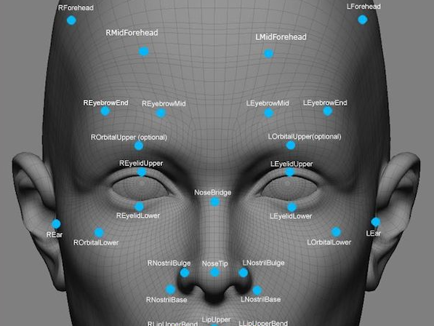

* Establishment of a virtual and physical AR Zone for demonstrations for corporate clients
* Interoperability with future Facebook and Google AR zone and world standards
* Prevention of the ‘overtake’ of humans by AI; or at least prolonging of this effect. Augmentation of human work effort by custom cloud-driven AI and automation via smart contract will allow human minds to focus on more creative or important tasks. Augmentation will provide a multiplier effect and allow humans to remain effective compared to standalone AI for a significant time into the future.

## How are we funded?

Assistive Reality will be funded by two sources: private investment from the founders group and an ICO for the **ARX** token on the Ethereum Blockchain from September 29th 2017 until October 20th 2017, or until the cap is reached. In order to conduct an ethical, responsible fundraising activity, we are observing the following conventions:

* Security and functional reviews conducted on Crowdsale contract
* Solidity best practice guidelines for ordering smart contract code
* All funds fully refundable if Crowdsale is unsuccessful
* Source code for contract published on GitHub (<https://github.com/AssistiveReality>)
* Capped Crowdsale with minimum and maximum caps
* SafeMath integer overflow functions used throughout
* Multi-sig wallets for funding and foundation
* Trezor hardware wallet for cold storage
* Company name purchased locally
* Business plan, banking services and funding from founders established

We are very driven to build a successful technology company and to bring Ethereum Blockchain technology to an even wider community. We also believe by establishing a high performance start-up a significant improvement in the credibility of future ICOs can be achieved.

The conditions of the Crowdsale itself are shown below, as enforced by the smart contract. Whomever sends Ether to this contract directly, or via the BuyTokens function, is considered a ‘participant’ in the Crowdsale.  
  
The ICO (ETH address **0xE75178c6fA2B0F1903145277413C32A00EB8c201**):

* Implement a standard ERC20-compliant token **ARX**
* Provides participants with 4,000 **ARX** Tokens per 1 ETH (*Note*: Dynamic supply; **no** tokens exist before the sale, and **no more** can be created after the sale!)
* Utilises Multi-Signature wallets for processing and hardware wallet cold-storage for ETH
* Supplies the Assistive Reality foundation multisig wallet an additional 10% of all **ARX** tokens, to reimburse future developers. This is achieved by adding 10% ARX tokens to the overall supply as the Crowdsale ends, and sending this to the Foundation multisig wallet.
* Allows refunds simply by calling the Refund function of the Crowdsale contract from the account you submitted ETH from, if the Crowdsale period elapses without reaching the minimum funding level.
* Supplies approximated Eth value for Cap totals for viewing only, normalised from Wei to make it easier for people to visually inspect ICO progress. E.g. ‘9 Eth min funding cap’ instead of ‘9000000000000000000’. Full resolution values are also provided.
* Allows verification of the total token supply
* Allows an emergency halt to occur should any part of the ICO or Blockchain require it
* Complies with the latest compiler version and deprecated Throw recommendations
* Is fully regression tested

## Crowdsale / ICO instructions

A number of wallets are compatible with our **ARX** Ethereum token ICO (**ARX** being an ERC20 token), such as:

MyEtherWallet (no download needed) <https://www.myetherwallet.com/>  
MetaMask (Firefox and Chrome browser add-on) <https://metamask.io/>  
Mist (Desktop) <https://github.com/ethereum/mist/releases>  
Parity (Desktop) <https://ethcore.io/parity.html>  
imToken (iPhone) <https://itunes.apple.com/us/app/imtoken/id1153230571?ls=1&mt=8>  
imToken (Android) <https://token.im/>

Contact us at [staff@aronline.io](mailto:staff@aronline.io) for more information about a specific wallet or query. It is important to consider that potential network congestion can cause temporarily higher fee requirements for the transactions. Our ICO is fully tested with Mist which successfully predicts the correct gas values, however we also have some comments below around the gas values you may need to expect for operation of our ICO contract.

The screenshots and instructions below will guide you through a few methods of participating in the Crowdsale, including configuring your Mist browser to ‘watch’ the Assistive Reality **ARX** token, and to send an **Ether** donation to the Crowdsale, and how to verify you have received your **ARX** tokens in return. The ARX tokens should be retained in your personal wallet until such time as you redeem them using our redemption smart contracts for aronline.io services or apps.

The ICO parameters, **address** and **JSON** interface definition are below:

|  |  |
| --- | --- |
| **Assistive Reality** ARX token offering on Ethereum public blockchain | |
| ICO Token, Symbol, Name | **ARX,** Assistive Reality |
| ICO Contract Address on Mainnet | **0xE75178c6fA2B0F1903145277413C32A00EB8c201** [**Etherscan link**](https://etherscan.io/address/0xE75178c6fA2B0F1903145277413C32A00EB8c201) |
| **Start** date/time (approx.) | **Friday 29 September 2017, 7:00PM GMT** |
| Start block | **4323576** |
| **End** date/time (approx.) | **Friday 20 October 7:00PM GMT** |
| End block | **4402956** |
| Duration | 79,380 blocks (approximately 21 days average) |
| ETH **softcap** funding level | 3,500 |
| ETH **hardcap** funding level | 70,000 |
| Type of sale | Dynamic (tokens are created & sent live, up to the cap) |
| Price | Static 4,000 tokens per ETH (0.00025) |
| Total token cap | 308,000,000 |
| Refund available if unsuccessful | Yes, by calling Refund() function in ICO contract |
| Security Reviewed | Yes (numerous) |
| Halt protect | Yes |
| Source code | <https://github.com/assistivereality> |
| JSON definition | [Click here to get the raw JSON](https://raw.githubusercontent.com/assistivereality/ico/master/jsonforICO.txt) for copy/paste or see Appendix A: JSON |
| Information URL | <https://aronline.io/ethereum-ico-crowdsale-instructions> |

**Participating:**

To participate in our ICO after the Start Block **4323576**, which should occur on the Ethereum main net Blockchain around Friday the 29th of September @ 7:00PM GMT (though when the block occurs can vary slightly) you have a few options, such as:

1. Use any of the wallets below to send **ETH** to the ICO contract address **0xE75178c6fA2B0F1903145277413C32A00EB8c201**

You will receive your tokens in return immediately. Mist recommends around 76,000 gas for the transaction on mainnet and has no problem with the transaction by default however during the ICO period fee contention can occur; if you experience issues, try a higher fee.

MyEtherWallet (no download needed) <https://www.myetherwallet.com/>  
MetaMask (Firefox and Chrome browser add-on) <https://metamask.io/>  
Mist (Desktop) <https://github.com/ethereum/mist/releases>  
Parity (Desktop) <https://ethcore.io/parity.html>  
imToken (iPhone) <https://itunes.apple.com/us/app/imtoken/id1153230571?ls=1&mt=8>  
imToken (Android) <https://token.im/>

1. Or, Use the Mist browser on a Synchronised Node to send ETH to the ICO contract address. You will receive your tokens immediately in a return transaction. You should also select ‘Contracts’, ‘Watch token’, then copy/paste the ICO contract address into the address field, and click OK once the browser fills in the remainder of the form with the ARX token information. This will enable you to see your tokens. See later in this section for screenshots.

**0xE75178c6fA2B0F1903145277413C32A00EB8c201**

1. Or, Use the Mist browser (or alternative) to execute the **BuyTokens** function in the Crowdsale contract, which looks like this and will send you tokens in return for your ETH. This function requires a very small amount of additional gas compared to sending ETH to the ICO address directly. Mist recommends around 76,000 by default though this can vary.

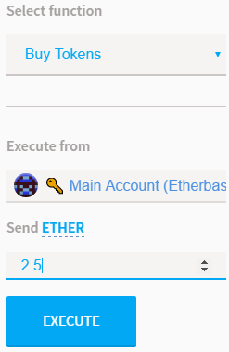

To do this, for example within the Mist browser, you would need to select ‘Contracts’ then ‘Watch contract’, then Copy/Paste the ICO token address into the address field:

1. Click contracts, scroll down to Custom Contracts, and click Watch Contract:

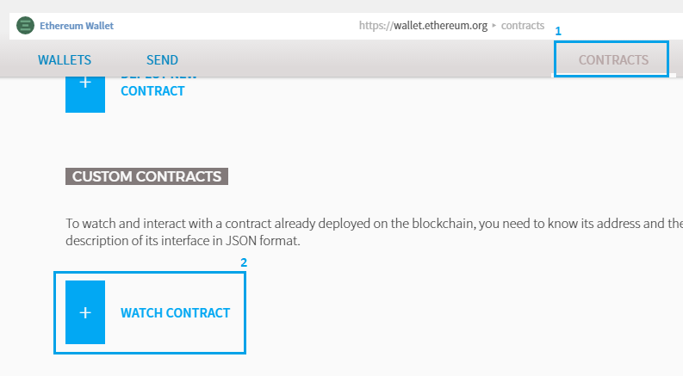

1. Paste in the contract address **0xE75178c6fA2B0F1903145277413C32A00EB8c201**
2. Enter a name such as **ARX token sale**
3. Paste in the contents of the JSON interface file, into the JSON field, contents available on GitHub here, or via the Appendix A: JSON.  
   <https://raw.githubusercontent.com/assistivereality/ico/master/jsonforICO.txt>

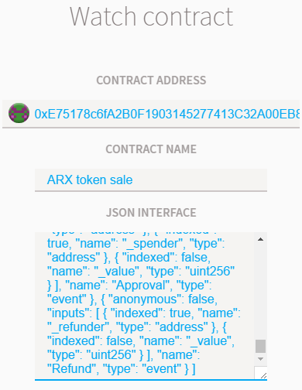

1. Click OK to proceed with watching the contract

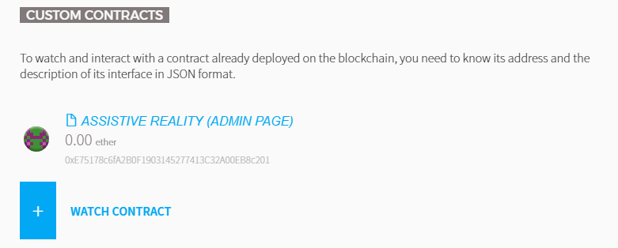

1. Now that you have added the contract to watch, you may also wish to watch the token so you can see when they are transferred to you. In mist, this is achieve by scrolling down the ‘Contracts’ page until you see ‘Custom Tokens’ then clicking ‘Watch Token’

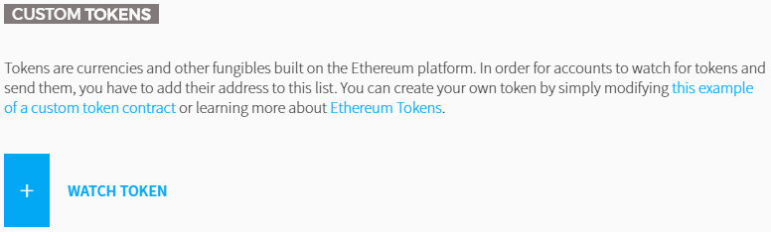

1. In the token watch entry form, paste in the token ICO contract address (**0xE75178c6fA2B0F1903145277413C32A00EB8c201**). The remainder of the form will auto-fill if you have entered the address correctly. Confirm you can see the ARX token details such as below, and click OK.

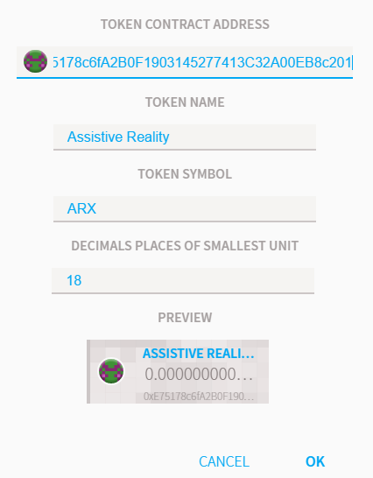

1. Now that you have both the token and contract being watched, you are free to use the functions provided by the Crowdsale contract, and will see the ARX tokens when they arrive into your wallet. Simply click on the Contract ‘**ARX** **Crowdsale’** in the ‘**Contracts’** section of Mist, and scroll down to see the functions, not all of which are available to you:

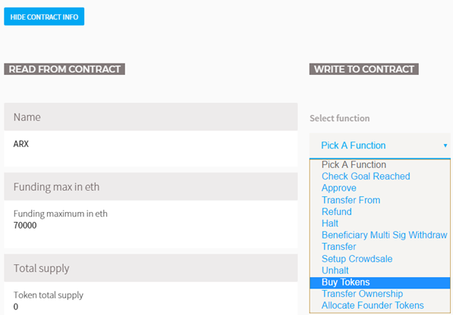

1. Enter the amount you wish to purchase, then click execute, authorise the transfer and you’ll see the exchange ETH/ARX occur and receive your ARX immediately (screenshots below are from testnet contract since the ICO disallows purchases until block 4402956)

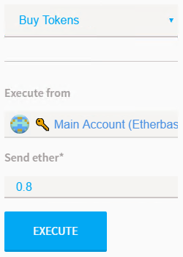

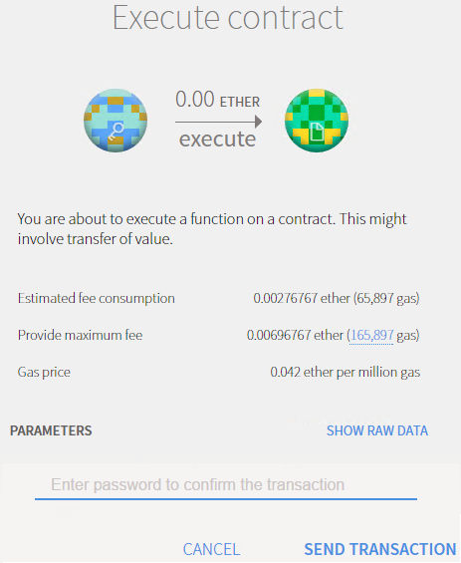

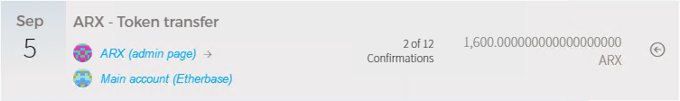

As a general recommendation we have observed that the gas price for interacting with the ICO contract is always fine at the default in Mist (and was between 50,000 and 80,000 for most functions), therefore a synchronised Mist wallet is recommended. However any of the common wallets that support (in full) ERC20 tokens can be used. If any fee contention or gas issues are experienced increase your paid fees until your transaction is successfully mined; though we have taken some effort to attempt to minimise the gas cost of the ARX ICO contract.

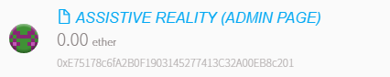

You can view information about the Crowdsale by watching the contract in Mist, then selecting it under Contracts and scrolling down from the header. Many fields will update live during the Crowdsale, and a few allow interaction during the sale (for example, the ‘approve’ function and the ‘balance of’ fields)

1. If the ICO is unsuccessful in reaching its minimum funding (softcap) level, as soon as the ‘**Funding End Block**’ has passed, users can execute the Refund() function from within the ICO contract to retrieve their ETH. We cannot manually send it back, you must execute Refund() from the account that submitted the ETH. Once submitted you will receive your ETH back immediately, and the ARX tokens will be removed from your balance. You can alternatively elect to retain/keep the ARX token as a souvenir. (Though we do not gain access to the submitted ETH unless the softcap is reached so we would suggest you to issue the Refund()).

Refunds only cost the fee/gas and you will receive 100% of your funds back.

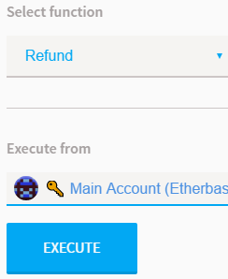

## Legal / disclaimer

By participating in the ARX ICO Token Crowdsale or making use of any information in this whitepaper or available on the aronline.io website, you agree to the following:

**GENERAL WARNING-**By using the services provided by Assistive Reality, you the (User) as either an Initial Coin Offering (hereinafter – ICO or Crowdsale) participant or (User) of Assistive Reality alpha products or services, fully understands and agrees with the following:

* User understands and acknowledges that ARX tokens will be provided by the ICO smart contract in the order that transactions are received by it and no alteration of this can be made by any party
* User understands that Assistive Reality carries no liability for the ability to take part in the ICO for reasons beyond the control of Assistive Reality including but not limited to the ICO duration, transaction mining delays and node-related issues
* Pending a successful ICO, Assistive Reality team members will be focused on completing the company start-up and delivering on milestones. However Assistive Reality undertakes no obligations to act on behalf and in the interests of User in the ICO being held in the future
* User understands that by transferring assets to Assistive Reality, User makes the final decision on deposition of cash or other assets and has no right of refund except that which is provided by the ICO smart contract code itself (that being, a 100% refund when capital raised is under the minimum cap and the ICO / crowdsale period has expired)

**TAX WARNING-**  
User understands that Assistive Reality does not act as a tax agent of User; User and Assistive Reality carry their tax obligations solely under the applicable laws of the country and location they reside in. Assistive Reality is not a tax agent and therefore shall not provide Users' financial information to any third parties. This information shall not be disclosed unless officially requested by government authorities.

**NO WARRANTIES-**All of the information provided within this whitepaper is provided “AS-IS” and with no warranties. No express or implied warranties of any type, including implied warranties of merchantability or fitness for a particular purpose, are made with respect to the information, or any use of the information, on this site or platform. Assistive Reality makes no representations and extends no warranties of any type as to the accuracy or completeness of any information or content in this whitepaper or regarding this platform.

**DISCLAIMER OF LIABILITY-**Assistive Reality specifically disclaims liability for incidental or consequential damages and assumes no responsibility or liability for any loss or damage suffered by any person as a result of the use or misuse of any of the information or content in this whitepaper or on the aronline.io website. Assistive Reality assumes or undertakes no liability for any loss or damage suffered as a result of the use, misuse or reliance on the information and content in this whitepaper or on the aronline.io website.

In no event shall Assistive Reality be liable to User for any special, indirect, incidental, consequential, exemplary or punitive damages (including lost or anticipated revenues or profits and failure to realise expected savings arising from any claim relating to the services provided by Assistive Reality) whether such claim is based on warranty, contract, tort (including negligence or strict liability) or otherwise or likelihood of the same.

**USE AT YOUR OWN RISK-**By using the ICO smart contract for ARX, the Assistive Reality platform or aronline.io website including but not limited to the transferring assets to Assistive Reality, User confirms that he undertakes and understand all the possible risks that directly or indirectly arise from the activity connected with User’s participation in the ICO and/or use of Assistive Reality services and products.

**FORCE-MAJEURE-**User understands that Assistive Reality will not be liable to User for any breach hereunder, including for failure to deliver or delays in delivery of the Services occasioned by causes beyond the control of Assistive Reality including but not limited to unavailability of materials, strikes, labour slowdowns and stoppages, labour shortages, lockouts, fires, floods, earthquakes, storms, droughts, adverse weather, riots, thefts, accidents, embargoes, war (whether or not declared) or other outbreak of hostilities, civil strife, acts of governments, acts of God, governmental acts or regulations, orders or injunctions, or other reasons, whether similar or dissimilar to the foregoing (each a “Force Majeure Event”).

**FINAL WARNING-**ICO participations can be can be considered High-Risk Trading; purchasing financial instruments via an ICO or utilising services offered on the website may result in significant losses or even in a total loss of all funds invested.

* No information provided on Assistive Reality’s platform or website should be interpreted as investment advice. It does not constitute an offer or invitation by Assistive Reality to any User to buy or to sell tokens or make any investment.
* User guarantees that he is a legally capable person of a majority age and complies with legal rules and applicable laws of the jurisdiction where the User lives.
* By participating in the ICO User confirms that he has read, understood and agree to comply with all restrictions set forth above.

#### **Appendix A: JSON definition for ICO**

[ { "constant": false, "inputs": [], "name": "checkGoalReached", "outputs": [ { "name": "response", "type": "bytes32" } ], "payable": false, "type": "function" }, { "constant": true, "inputs": [], "name": "name", "outputs": [ { "name": "", "type": "string", "value": "Assistive Reality" } ], "payable": false, "type": "function" }, { "constant": false, "inputs": [ { "name": "_spender", "type": "address" }, { "name": "_amount", "type": "uint256" } ], "name": "approve", "outputs": [ { "name": "success", "type": "bool" } ], "payable": false, "type": "function" }, { "constant": true, "inputs": [], "name": "fundingMaxInEth", "outputs": [ { "name": "fundingMaximumInEth", "type": "uint256", "value": "0" } ], "payable": false, "type": "function" }, { "constant": true, "inputs": [], "name": "totalSupply", "outputs": [ { "name": "tokenTotalSupply", "type": "uint256", "value": "0" } ], "payable": false, "type": "function" }, { "constant": true, "inputs": [], "name": "tokensPerEthPrice", "outputs": [ { "name": "", "type": "uint256", "value": "0" } ], "payable": false, "type": "function" }, { "constant": false, "inputs": [ { "name": "_from", "type": "address" }, { "name": "_to", "type": "address" }, { "name": "_amount", "type": "uint256" } ], "name": "transferFrom", "outputs": [ { "name": "success", "type": "bool" } ], "payable": false, "type": "function" }, { "constant": true, "inputs": [], "name": "decimals", "outputs": [ { "name": "", "type": "uint8", "value": "18" } ], "payable": false, "type": "function" }, { "constant": true, "inputs": [], "name": "isCrowdSaleSetup", "outputs": [ { "name": "", "type": "bool", "value": false } ], "payable": false, "type": "function" }, { "constant": true, "inputs": [], "name": "beneficiaryMultiSig", "outputs": [ { "name": "", "type": "address", "value": "0x0000000000000000000000000000000000000000" } ], "payable": false, "type": "function" }, { "constant": false, "inputs": [], "name": "refund", "outputs": [], "payable": false, "type": "function" }, { "constant": true, "inputs": [], "name": "standard", "outputs": [ { "name": "", "type": "string", "value": "ARX" } ], "payable": false, "type": "function" }, { "constant": true, "inputs": [], "name": "founderTokensAvailable", "outputs": [ { "name": "", "type": "bool", "value": false } ], "payable": false, "type": "function" }, { "constant": false, "inputs": [], "name": "halt", "outputs": [], "payable": false, "type": "function" }, { "constant": true, "inputs": [], "name": "foundationFundMultisig", "outputs": [ { "name": "", "type": "address", "value": "0x0000000000000000000000000000000000000000" } ], "payable": false, "type": "function" }, { "constant": true, "inputs": [ { "name": "_owner", "type": "address" } ], "name": "balanceOf", "outputs": [ { "name": "balance", "type": "uint256", "value": "0" } ], "payable": false, "type": "function" }, { "constant": true, "inputs": [], "name": "amountRaisedInWei", "outputs": [ { "name": "", "type": "uint256", "value": "0" } ], "payable": false, "type": "function" }, { "constant": false, "inputs": [ { "name": "_amount", "type": "uint256" } ], "name": "beneficiaryMultiSigWithdraw", "outputs": [], "payable": false, "type": "function" }, { "constant": true, "inputs": [], "name": "amountRaisedInEth", "outputs": [ { "name": "amountRaisedSoFarInEth", "type": "uint256", "value": "0" } ], "payable": false, "type": "function" }, { "constant": true, "inputs": [], "name": "owner", "outputs": [ { "name": "", "type": "address", "value": "0x7a29e1343c6a107ce78199f1b3a1d2952efd77ba" } ], "payable": false, "type": "function" }, { "constant": true, "inputs": [], "name": "fundingEndBlock", "outputs": [ { "name": "", "type": "uint256", "value": "0" } ], "payable": false, "type": "function" }, { "constant": true, "inputs": [], "name": "remainingCapInEth", "outputs": [ { "name": "remainingHardCapInEth", "type": "uint256", "value": "0" } ], "payable": false, "type": "function" }, { "constant": true, "inputs": [], "name": "symbol", "outputs": [ { "name": "", "type": "string", "value": "ARX" } ], "payable": false, "type": "function" }, { "constant": true, "inputs": [], "name": "isCrowdSaleFinished", "outputs": [ { "name": "", "type": "bool", "value": false } ], "payable": false, "type": "function" }, { "constant": true, "inputs": [], "name": "fundingMinInEth", "outputs": [ { "name": "fundingMinimumInEth", "type": "uint256", "value": "0" } ], "payable": false, "type": "function" }, { "constant": false, "inputs": [ { "name": "_to", "type": "address" }, { "name": "_amount", "type": "uint256" } ], "name": "transfer", "outputs": [ { "name": "success", "type": "bool" } ], "payable": false, "type": "function" }, { "constant": false, "inputs": [ { "name": "_fundingStartBlock", "type": "uint256" }, { "name": "_fundingEndBlock", "type": "uint256" } ], "name": "SetupCrowdsale", "outputs": [ { "name": "response", "type": "bytes32" } ], "payable": false, "type": "function" }, { "constant": true, "inputs": [], "name": "fundingMinInWei", "outputs": [ { "name": "", "type": "uint256", "value": "0" } ], "payable": false, "type": "function" }, { "constant": true, "inputs": [], "name": "foundationFundTokenCountInWei", "outputs": [ { "name": "", "type": "uint256", "value": "0" } ], "payable": false, "type": "function" }, { "constant": true, "inputs": [], "name": "halted", "outputs": [ { "name": "", "type": "bool", "value": false } ], "payable": false, "type": "function" }, { "constant": false, "inputs": [], "name": "unhalt", "outputs": [], "payable": false, "type": "function" }, { "constant": true, "inputs": [], "name": "fundingStartBlock", "outputs": [ { "name": "", "type": "uint256", "value": "0" } ], "payable": false, "type": "function" }, { "constant": true, "inputs": [], "name": "remainingCapInWei", "outputs": [ { "name": "", "type": "uint256", "value": "0" } ], "payable": false, "type": "function" }, { "constant": false, "inputs": [], "name": "BuyTokens", "outputs": [], "payable": true, "type": "function" }, { "constant": true, "inputs": [ { "name": "_owner", "type": "address" }, { "name": "_spender", "type": "address" } ], "name": "allowance", "outputs": [ { "name": "remaining", "type": "uint256", "value": "0" } ], "payable": false, "type": "function" }, { "constant": true, "inputs": [], "name": "CurrentStatus", "outputs": [ { "name": "", "type": "string", "value": "Crowdsale deployed to chain" } ], "payable": false, "type": "function" }, { "constant": true, "inputs": [], "name": "fundingMaxInWei", "outputs": [ { "name": "", "type": "uint256", "value": "0" } ], "payable": false, "type": "function" }, { "constant": false, "inputs": [ { "name": "newOwner", "type": "address" } ], "name": "transferOwnership", "outputs": [], "payable": false, "type": "function" }, { "constant": true, "inputs": [], "name": "admin", "outputs": [ { "name": "", "type": "address", "value": "0x7a29e1343c6a107ce78199f1b3a1d2952efd77ba" } ], "payable": false, "type": "function" }, { "constant": false, "inputs": [], "name": "AllocateFounderTokens", "outputs": [], "payable": false, "type": "function" }, { "inputs": [], "payable": false, "type": "constructor" }, { "payable": true, "type": "fallback" }, { "anonymous": false, "inputs": [ { "indexed": true, "name": "_sender", "type": "address" }, { "indexed": false, "name": "_eth", "type": "uint256" }, { "indexed": false, "name": "_ARX", "type": "uint256" } ], "name": "Buy", "type": "event" }, { "anonymous": false, "inputs": [ { "indexed": true, "name": "_from", "type": "address" }, { "indexed": true, "name": "_to", "type": "address" }, { "indexed": false, "name": "_value", "type": "uint256" } ], "name": "Transfer", "type": "event" }, { "anonymous": false, "inputs": [ { "indexed": false, "name": "_from", "type": "address" }, { "indexed": false, "name": "_value", "type": "uint256" } ], "name": "Burn", "type": "event" }, { "anonymous": false, "inputs": [ { "indexed": true, "name": "_owner", "type": "address" }, { "indexed": true, "name": "_spender", "type": "address" }, { "indexed": false, "name": "_value", "type": "uint256" } ], "name": "Approval", "type": "event" }, { "anonymous": false, "inputs": [ { "indexed": true, "name": "_refunder", "type": "address" }, { "indexed": false, "name": "_value", "type": "uint256" } ], "name": "Refund", "type": "event" } ]